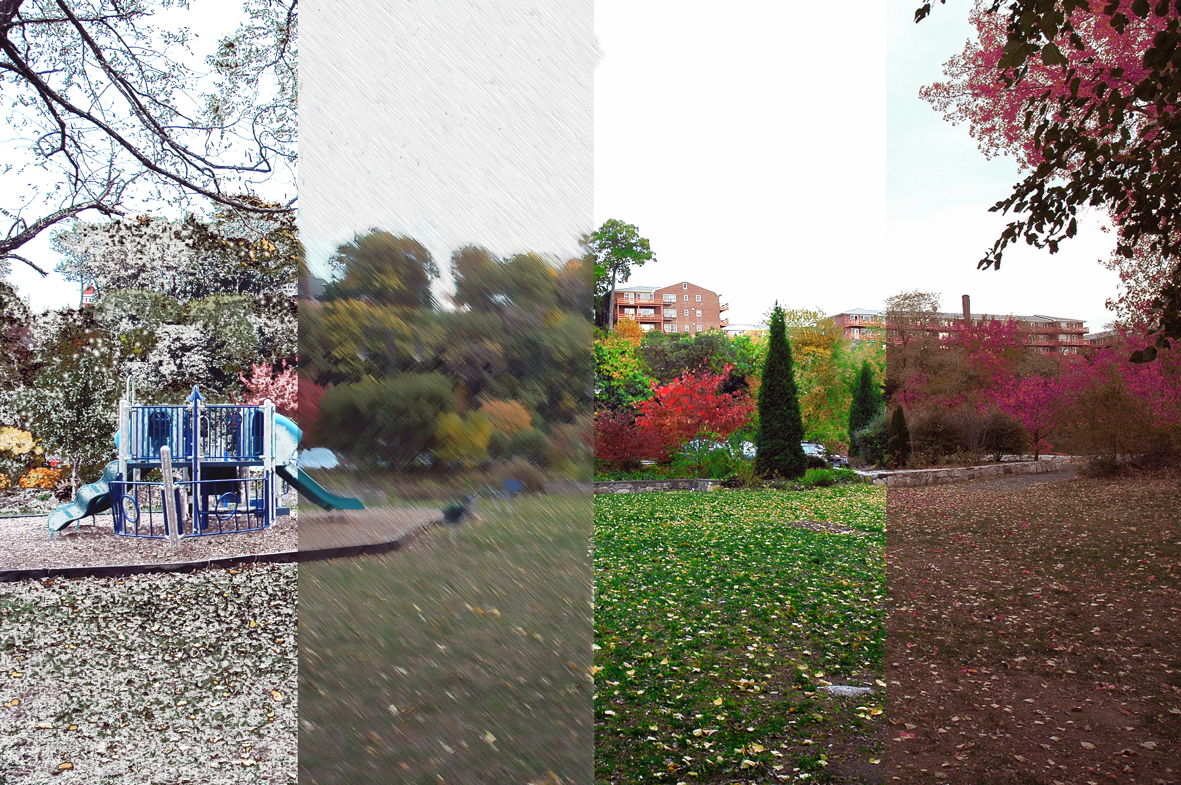

Four Seasons Landscape

Getting Started
- Go to the pictures you have taken and choose a horizontal landscape to work with. Make sure the photo is interesting and that there’s landscape (grass, trees…) in all areas.
- Resize your picture to 300 resolution, 8” high x 10” wide (you will probably need to crop it to make it that size). You will divide the landscape into four equal parts using guides. In each section you will change the colors and textures, add patterns and gradients, and use filters and image adjust to depict a season. You will decide on your own what to add to each section. Use the tools and effects we have already learned and experiment and try new things we haven’t already covered in class.

Dividing the Landscape
- Using Guides. Point the pointer over the left ruler of the document. Drag a blue guide two and a half inches over to create the first section. Continue to drag guides from the left ruler until you have divided the picture up equally into four sections, all measuring 2-1/2” inches wide.

Cutting and Pasting
- Using the Rectangular Marque tool select the first section on the left. Under Edit choose Copy, next under Edit choose Paste. Pasting creates a new layer on the layers palette. This newly created layer will automatically be called Layer 2. Rename it to Winter.
- Click on the background layer again and use the Rectangular Marque tool select the second section of the landscape. Under Edit choose Copy, next under Edit choose Paste. This newly created layer will automatically be named Layer 3. Rename it to Spring.
- Click on the background layer again and use the Rectangular Marque tool select the third section of the landscape. Under Edit choose Copy, next under Edit choose Paste. This newly created layer will automatically be named Layer 4. Rename it to Summer.
- Click on the background layer again and use the Rectangular Marque tool select the fourth section of the landscape. Under Edit choose Copy, next under Edit choose Paste. This newly created layer will automatically be named Layer 5. Rename it to Fall.
- Now you have created a layer for each section. Next you will add colors, painting and other effects to change each section to reflect a season of the year.
- SAVE YOUR WORK! Under File choose Save As and name your document with your lastname.firstname.fourseasonslandscape as you are going. Be sure to keep it as a Photoshop document until you are complete.

Winter Section
- Click on Layer 2, Winter. Deselect the Eye icon in the other layers and background layer so you are only working on one layer at a time. Add colors and textures. Using the skills you have learned in Photoshop you will add things to this section to imply winter. Change the color of the sky, add snow or wind. Think of the colors you see in winter: cool blues, purples and greys. What happens to the texture of the trees or the grounds?
- Suggestions: under Image choose Adjust, then choose Replace Color. Move the pointer to the area where you want to change the color. You will see the area light up in the Replace Color dialog box. The pointer will automatically change into the eye dropper. Click where you want to change color. You will see the area light up in the dropper. Next move the sliders around in the dialog box until you capture the color you want. Click ok when you are done. Repeat the process as many times as needed to change the entire sky or other area you are changing. Each color must be done separately.
- Try using different types of paint brushes to add snow or dead leaves. Add whatever you think is necessary to create the feel of winter. SAVE YOUR WORK!

Spring Section
- Click on Layer 3, Spring. Add colors and textures. Create this section to look like Spring. What colors do you think of when you think of spring? Change the sky and add buds on the trees or flowers. Add weather to the picture. Try using filters to add rain or wind.
- Suggestions: Using the Magic Wand tool, select all the background areas in the picture. Under Filter choose Brush Strokes then choose Angle Strokes. In the Angled Strokes dialog box move the sliders around until you get the desired effect. Choose ok. Hint: if the sky doesn’t have information for the brush strokes, you can go to the Filter pull down menu and Add Noise, and then choose Brush Strokes. You may also choose the Blur filter to soften the background.
- Continue to add things to the section until you have achieved the look of Spring. SAVE YOUR WORK!

Summer Section
- Click on layer 4, Summer. Add colors and textures. Create this section to imply Summer.
- Suggestions: Use a variety of paintbrushes. Choose the Paintbrush tool. On the Paintbrush options bar click the arrow next to the current brush. Choose a brush. Paint in lush full trees in bright summer colors. Again change the sky color or paint the bark of a tree. Adjust the brightness and saturation of the scene. Continue to change and SAVE YOUR WORK!

Fall Section
- Click on layer 5. Add colors and textures. Create this section to look like Fall. Make the sky stormy or with clouds. Use the fall colors of orange, yellow, brown and red. Add falling leaves.

Finishing the Work
- Put the eye icons back on all the layers. How do the different layers work together? Is any part cut off, and does each season look distinctive from one another?
- Once you are happy with your work, merge the layers and save as jpeg! You are done! Save your work and put it in your own personal folder of completed work and the shared drive under the 4 Seasons Landscape folder.

