Photographic Imaging

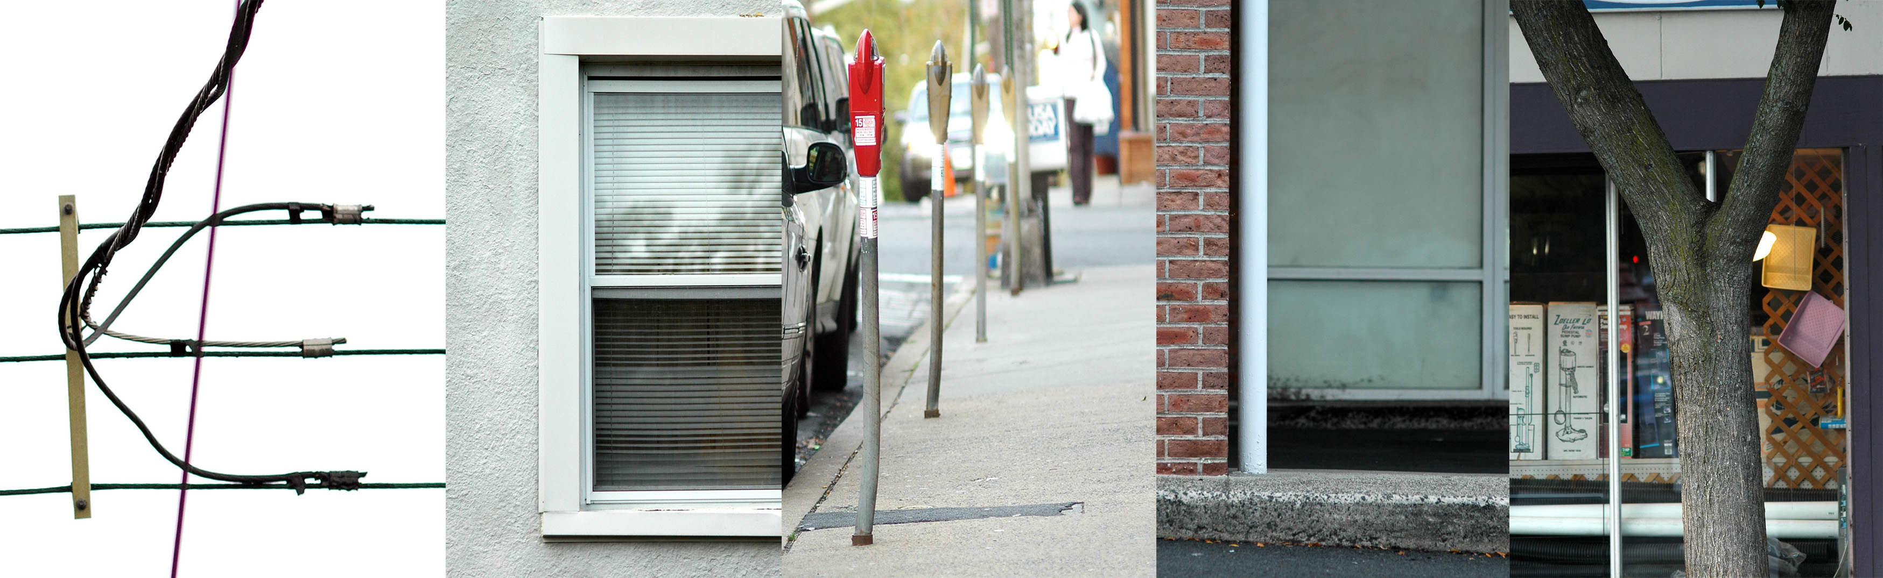

Name Project- Digital Photography

In this project, you will create a document of your name, using your digital camera to find representations of the alphabet. For example, a side of a building hitting a sidewalk might make an L, or a key hole would make an O. You have to use at least four letters for the assignment- if your name is shorter, please do your first name and last initial. I suggest taking at least two separate pictures of your letters, in case one isn’t too exciting or is out of focus, etc. PLEASE NOTE that if a picture is out of focus, there is nothing you can do in Photoshop to make it in focus! Take care to have sharp photographs!

Objectives:
Introduction to using a digital DSLR
Use of the element of line
Introduction to Photoshop with introduction to Layers, Rulers, and Desaturation
Steps:
- Take the pictures then download them onto the R Drive under your folder name in the appropriate class, as well as under your student number folder.
- To download the photographs
  - Use the USB cord and attach to the USB port on the back of the computer and attach it to the camera- the spot on the camera is on the left side, next to the arrow button. Turn the camera on- you will see PC on the top.
  - It will open up in iphoto automatically where a menu will pop up saying camera name, Nikon D80, whether you want to name the event, and whether you would like to import the photographs. Say yes.
  - Another menu will pop up asking if you would like to delete the photographs on the camera. Click no, you are going to keep the photographs.
  - Look at the thumbnails of the photographs on iphoto and immediately delete the ones that are bad/ under or over exposed, out of focus, etc.
  - Double click on the thumbnail to get a closer view of the image/s.
  - Once you find a photograph you like, move it off iphoto and to the side to the desktop and rename clicking on the name to whichever letter you want.
  - Open up Photoshop and open the letter, finding it on the desktop. Save to your student folder.
- Open up Photoshop and make a new document using the preset tool that is 5” high x 7” wide with 300 resolution.
- Go to “Image” then “Rotate Canvas” and rotate it 90 degrees to have it set up as a landscape- horizontally.
- Save as your first and last name and name, like this- kelly.moncure.name. This is the background of the name.
- Open up “view” and click on “rulers”. Click onto the top ruler and drag a blue guide to 1” down. Release. Then click and drag the top ruler and drag the blue guide to 4” down. Release.
- Click the left ruler and drag a blue guide to 6 1/2”. Release. Click on the left ruler and drag a blue guide to ½” from the left. Release. Note that these are to help make your name centered on the page and straight on the top and bottom.
- Click open up your first photograph of your first letter in your first name in Photoshop by right clicking on the thumbnail and selecting Photoshop.
- Using the crop tool, crop to where the letter looks best.
- Change to black and white by going to menu, image- adjustments- desaturate.
- Go to image- adjustments, adjust the brightness/contrast to make the letter stand out.
- Go to image- image size and change the size of the letter to 2 1/2” height with 300 resolution- the size may vary depending on the amount of letters used.
- Use the move tool to move the letter to the initial blank document to make a new layer. Put the letter in the far left and title each layer in box to what each letter is.
- Open up the second letter in photoshop. Do the same as the above until you are done bringing over letters.
- If you need to change the size of any of the letters, you may use the “transform” key. Use the pull down menu under “edit” and then go to “transform” then “scale”. You need to change the size to the appropriate one, then apply it by clicking on another key in the menu bar, say, the rectangular marquee key.
- Note that if you want to make changes to any of the individual letters, you need to select the correct layer in order to be able to make them!
- Keep saving your work as a photoshop file- once it’s saved as a jpeg, you can’t work with it again because it will merge the layers and you won’t be able to work on it further!
- You may want to save the individual letters after you crop them in case you need to do adjustments.
- After you have created the document, merge all layers using layer- merge visible. Save as a jpeg titling it as your firstname.lastname.name and keeping it in your folder.
- You can have the letters touching each other or with white space around them- just be sure if you do have white space, that the space is equal from letter to letter.

Graded on:
Originality (30 points) Time on Task (10 points) Correct Scale (20 points)
Full name (10 points) Computer work (10 points) Photography (20 points)

