Mrs. Moncure
Portrait Photography

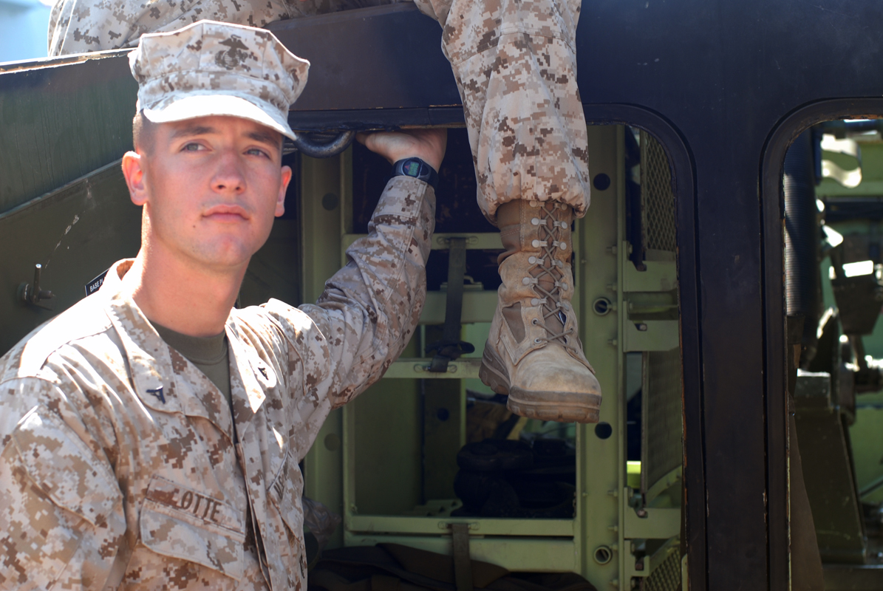

This portrait was taken at ISO160, 50 mm, f/5 at 1/125th of a second.
I was standing about four feet away from the subject and the sun was over his left shoulder. I think this photograph was successful because the lighting was even, I think the boot coming down shows a bit of personality, and it gives the look of a day in the life of a military man.

This portrait was taken at 1SO 160, 50 mm, f 5.6 at 1/200th of a second.
I was standing about five feet away from the subject and the sun was coming in from the left hand side. I wish that the woman was not in the photograph- since I was so keen on capturing the soldier’s stance, I did not look at the full frame and see that she was in the way. If I moved over about four feet I could have gotten a better photograph, but I may end up cropping this.

